Introduction to Digital Logic

EECS/CSE 31L

**Assignment 4 Design Report**

**Designing Register**

Prepared by: Derek Yang

Student ID: 63118832

EECS Department

Henry Samueli School of Engineering

University of California, Irvine

November, 8, 2014

1 REGISTER Description

This 32-bit register is designed to receive a 32-bit input and read out the 32-bit input as the 32-bit output if write enable is active. It supports asynchronous and synchronous resets, meaning when the asynchronous signal is enabled, the output will be 0 whether the clock signal is on or off and when the synchronous signal is enabled, the out should be 0 only when the clock signal is on. This design also features an incrementing feature, which increments the output by one.

2 Input/Output Port Description

|  |  |  |  |
| --- | --- | --- | --- |
| Port Name | Port Size | Port Type | Description |
| clk | 1 | IN | Clock Signal |
| rst_a | 1 | IN | Asynchronous Reset Signal |
| rst_s | 1 | IN | Synchronous Reset Signal |
| inc | 1 | IN | Increment Signal |
| we | 1 | IN | Write Enable Signal |
| din | 32 | IN | 32-bit Input |
| dout | 32 | OUT | 32-bit Output |

3 Design Schematic

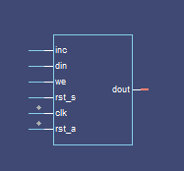

4 Wave Map

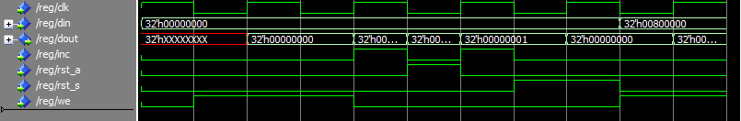

1 REGISTER FILE Description

This 32-bit Register File is a single-port register file that supports two read and one write at each clock cycle. This register file only has a synchronous reset and does not have an asynchronous reset, meaning the only way to reset the data is when there is a rising a clock edge. Every time the rising clock edge appears, it will read two addresses the user inputs and writes a 32-bit into the address the user inputs.

2 Input/Output Port Description

|  |  |  |  |
| --- | --- | --- | --- |
| Port Name | Port Size | Port Type | Description |
| clk | 1 | IN | The Clock Cycle |
| rst_s | 1 | IN | Synchronous Reset Signal (1 = Reset) |
| we | 1 | IN | Write Enable Signal |
| raddr_1 | 3 | IN | 1st Read Address Signal |
| raddr_2 | 3 | IN | 2nd Read Address Signal |
| waddr | 3 | IN | Write Address Signal |
| rdata_1 | 32 | OUT | 1st Read Data Signal |
| rdata_2 | 32 | OUT | 2nd Read Data Signal |
| wdata | 32 | IN | Write Data Signal |

3 Design Schematic

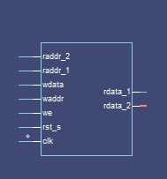

4 Wave

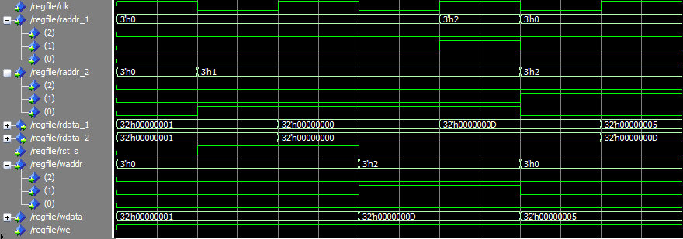

1 COUNTER Description

This 32bit counter takes a 32bit input and counts up or down depending on the ascending mode given, 0 meaning decrement and 1 meaning increment. This counter circuit is also synchronous, meaning it will rely on the clock cycle to take action, so only when the clock is 1, the counter will increment or decrement. The preload mode also enables the user to load their input into the counter. There is also a reset mode, where when enabled, all inputs and counts will return to 0.

2 Input/Output Port Description

|  |  |  |  |
| --- | --- | --- | --- |
| Port Name | Port Size | Port Type | Description |
| clk | 1 | IN | The Clock Cycle |
| rst_s | 1 | IN | Synchronous Reset Signal (1 = Reset) |
| asc | 1 | IN | Ascending Signal (0 = Decrement, 1 = Increment) |
| preload | 1 | IN | Mode Selection (0=Arithmetic, 1=Logical) |
| din | 32 | IN | 32-bit Input |
| dout | 32 | OUT | 32-bit Output |

3 Design Schematic

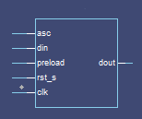

4 Wave

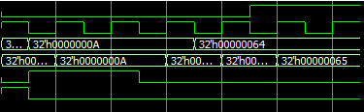

asc

clk

din

dout

preload

rst_s